Strayer University

USE CASES

Week 6

Use Case Assignment 2

for the

Course of

Systems Analysis and Development

05/15/17

By

Kennedy Kabaso.

Professor: Irene Hoskins.

**USE CASES FOR ATM**

I would like to describe how someone is going to withdraw money from the ATM. Then how he or she is going to make an account deposit and lastly, I will describe a use case dependency on which someone is going to make an account transfer. I would describe this steps in details how all these are going to be done. Then show them in a flow chart and a use case diagram which is going to make it easy to be understood by anyone. Before I go any further, I would like to define this term. What is a use case? According to Wikipedia and I quote “In software and systems engineering, a **use case** is a list of actions or event steps, typically defining the interactions between a role (known in the Unified Modeling Language as an actor) and a system, to achieve a goal. The actor can be a human or other external system”. Now that I have defined what it is, am going to go through them one by one. I will start with the first one which is money withdraw.

**MONEY WITHDRAW.**

In my case the actor is going to be a bank Customer and the system is an ATM. I am going to put down these steps which are involved in withdrawing money from the ATM. The following are the steps which the Customer of the bank (Actor) is going to do on the ATM which is the system as I have mentioned already. The first thing anybody do when the approach the ATM is as follows.

1. Customer enters bank card into the ATM.
2. The ATM asks the Customer to enter Personal Identification Number (PIN).
3. Customer enters PIN number.
4. The System validates PIN.
5. The ATM asks the Customer to choose what her/she wants to do next.
6. Customer chooses to withdraw money.
7. The ATM asks the Customer to choose from which account.
8. Customer chooses either saving or checking.
9. The ATM asks the Customer to enter the amount he/she wants.
10. Customer enters the amount.
11. The ATM dispenses the money and updates the new balance.
12. The Card is going to be ejected from the ATM
13. The customer is asked to print a receipt or not.
14. The Customer enters yes or no.
15. The ATM print the receipt or not depends on the choice of the Actor.

The above steps are the ones which are needed to withdraw money from the account. I am going to put this in form of a flow chart and the diagram below.

**Flow Chart for the withdraw of money from ATM.**

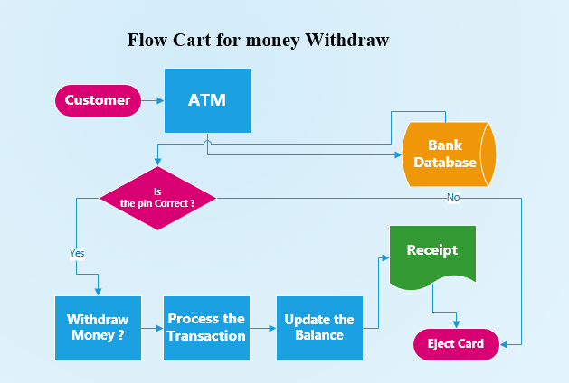

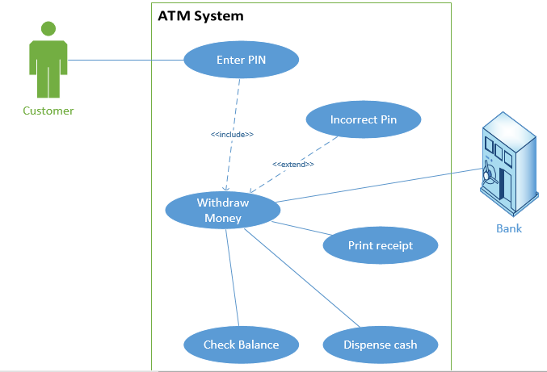

**ACCOUNT DEPOSIT.**

The next thing am going to do isto put down the steps which are involved in depositing money into the ATM. It is a smooth process which is acceptable all over the world. The following are the steps which the Customer of the bank (Actor) as before is going to do on an ATM (System) which is going to update his account at the bank after he is done with the whole process after the person in charge opened the machine and make sure the exactly amount deposited is the same. If there is an error, the account holder is going to be informed and the error corrected. The steps are as follows for making the deposit,

1. Customer enters bank card into the ATM.
2. The ATM asks the Customer to enter Personal Identification Number (PIN).
3. Customer enters PIN number.
4. The System validates PIN.
5. The ATM asks the Customer to choose what to do next.
6. Customer chooses to deposit money.
7. The ATM asks the Customer to choose to which account.
8. Customer chooses either saving or checking.
9. The ATM asks the Customer to choose either to deposit check or cash.
10. Customer enters the choice.
11. The ATM door opens for the choice.
12. Customer inserts his choice.
13. The ATM updates the new balance.
14. The Card is going to be ejected from ATM
15. The customer is asked to print a receipt or not.
16. The Customer enter yes or no.
17. The ATM prints the receipt or not.

The above steps are the ones which are needed to deposit money into the account of the Customer. I am going to put these in form of the diagram and flow chart below.

**Flow Chart for depositing money into the account using ATM.**

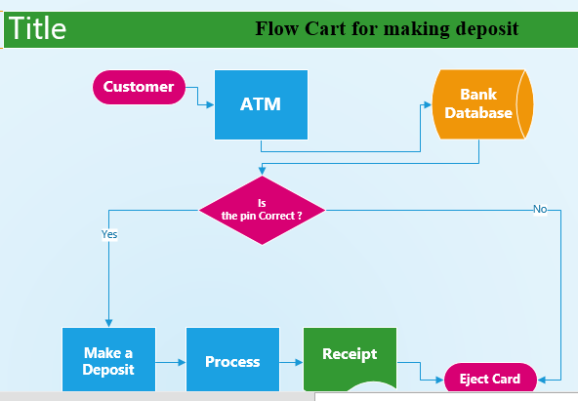

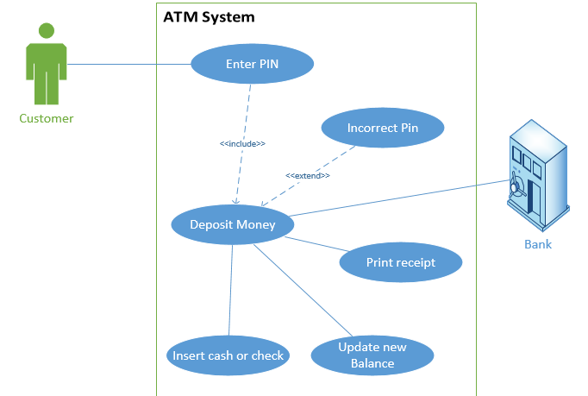

**Money Transfer.**

The last thing am going to do isto put down the steps which are involved in transferring money to another account using the ATM. The following are the steps which the Customer of the bank (Actor) as before is going to do on an ATM which is the system that is going to update his account at the bank.

1. Customer enters bank card into the ATM.
2. The ATM asks the Customer to enter Personal Identification Number (PIN).
3. Customer enters PIN number.
4. The System validates PIN.
5. The ATM asks the Customer to choose what to do next.
6. Customer choose to transfer money.
7. The ATM asks the Customer to choose from which account.
8. Customer choose either saving or checking.
9. The ATM validates available funds.
10. Customer enters amount for transfer.
11. The ATM update the new balance.
12. The Card is going to be ejected from ATM
13. The customer is asked to print a receipt or not.
14. The Customer enters yes or no.
15. The ATM prints the receipt or not.

The above steps are the ones which are needed to transfer money from one account into another. I am going to put down these steps in form of the flow chart and the diagram below.

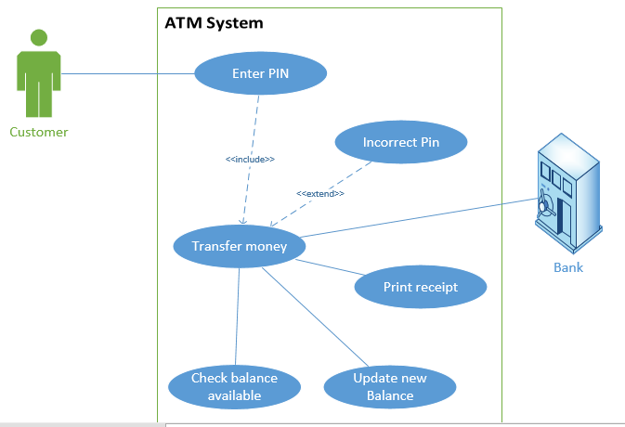**Flow Chart for Transferring money using an ATM.**

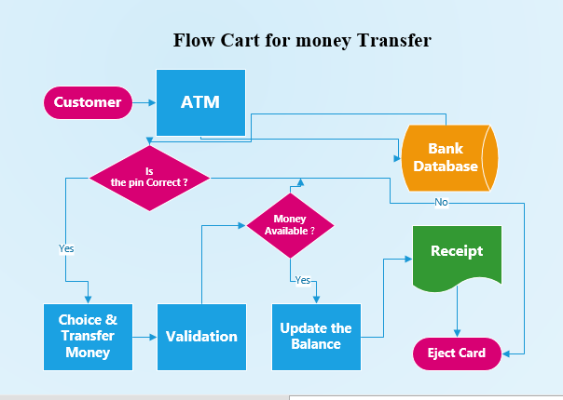

The ethical issues that the use case exposes about the development or use of the ATM system are crime and remotely access to the account of any person at the system and the pin number. Crime is one of the biggest issue with ATM. Thieves can easily rub someone withdrawing money from the ATM at gun point. They can follow behind and get the money he or she withdraws and disappear. A lot of people have been robbed most of the time and other killed on these machines which has made the banks to install cameras on every ATM machine in the country. Besides theft, there is also another system of remotely access to the account of the person using the ATM. IT personal who knows how to hack into the account of the personal using the ATM can easily get information of that personal remotely, go make a duplicate of an ATM card and start using a newly made duplicate ATM card and do all kind of things with it.

Finally, the above-mentioned processes of withdrawing, transferring and depositing money if done properly will result in better service using the ATM. It is quick and can be done at any time of the day or night without waiting for the bank to open. Moreover, it is a convenience way of doing some financial transaction.

**Citation**

<https://en.wikipedia.org/wiki/Use_case>

<https://creately.com/diagram-type/objects/flowchart>

<http://www.uml-diagrams.org/use-case-reference.html>

<http://casecomplete.com/product/tour>

<http://searchsoftwarequality.techtarget.com/definition/use-case>